**Measurement of Optical Rotation of Matter**

**Yihang Zou**

**School of Future Technology**

**South China University of Technology**

**Abstract**

Optical rotation, also known as polarization rotation or circular birefringence, is the rotation of the orientation of the plane of polarization about the optical axis of linearly polarized light as it travels through certain materials. Circular birefringence and circular dichroism are the manifestations of optical activity. Optical activity occurs only in chiral materials, those lacking microscopic mirror symmetry. Unlike other sources of birefringence which alter a beam's state of polarization, optical activity can be observed in fluids. This can include gases or solutions of chiral molecules such as sugars, molecules with helical secondary structure such as some proteins, and also chiral liquid crystals. It can also be observed in chiral solids such as certain crystals with a rotation between adjacent crystal planes (such as quartz) or metamaterials. This technical report will explore the principle behind optical rotation and the techniques and instruments commonly used for measuring optical rotation. Then it will outline the procedure and data processing of the experiment.

**Key Words: Optical Rotation of Matter, Polarized Light, Spectrophotometer, Marius Law, Beer-Lambert Law**

**Acknowledgement:** The technical report was finished under the guidance of Mr. Kaiyu Mao. He gave me the opportunity and support to finish the experiment, and he gave me some valuable comment on the format of the report which helped me form a better report. I would like to express my sincere appreciation and gratitude to Him.

**Table of Contents**

Acknowledgement:

1. Introduction
   1. Background
   2. History
   3. Experimental Instrument
2. Experiment
   1. Analysis and Explanation of Relevant Principles
      1. The Principle of Optical Rotation
      2. The Formula of Optical Rotation
      3. Malus Law
         1. Principles
         2. Malus Law Formula
      4. The Directionality of Material Rotation
   2. Purposes of the Experiment
   3. Procedures
      1. Determine the Polarization of the Light and Verify Malus Law
      2. Measuring the Optical Rotation of Glucose Solution
   4. Original Data and processing
      1. Determining the Polarization of Light with a Single Polarizer
      2. Determining the Polarization of Light with Multiple Polarizers
      3. Verifying Malus' Law
      4. Measuring the Optical Rotation of Glucose Solution
   5. Data Analysis
3. Discussion
   1. Beer-Lambert Law Applying on the Optical Rotation
      1. The Beer-Lambert Law
      2. The Formula of Beer-Lambert Law
      3. The Application of Beer-Lambert Law
      4. Pros and Cons of the Method
   2. Left and Right Spin Light Elimination Method
      1. Principles
      2. Content Step
      3. Advantages of the Method
4. Conclusions
5. References

**List of Figures**

Figure 1 OEX-PSP polarized optical rotation experimental instrument

Figure 2 The specific explanation of optical rotation formula

Figure 3 Polarized light passes through the polarizer

Figure 4 Schematic diagram of polarized light (1)

Figure 5 Schematic diagram of polarized light (2)

Figure 6 Single polarizer determines the polarization of the light source

Figure 7 Using polarizers and detectors to determine the polarization of the light source

Figure 8 Verifying Malus' Law (1)

Figure 9 Verifying Malus' Law (2)

**List of Tables**

Table 1 Angle value corresponding to single polarizer

Table 2 Angle value corresponding to multiple polarizers

Table 3 Data obtained from the Malus experiment

Table 4 Original data of experiment for measuring the optical rotation of glucose solution

1. **Introduction**

**1.1 Background**

The optical rotation property of the medium reflects the macroscopic phenomenon of the interaction process between light and matter, from which the important information about the molecular structure of matter can be obtained. When plane polarized light passes through certain substances in a magnetic field, the vibrating surface rotates, which is called the Faraday magneto optical effect. This property of matter is called Magneto genic optical rotation, which indicates the connection between optical and magnetic phenomena. A polarimeter is an instrument for measuring the optical rotation of substances. By measuring the optical rotation of the sample, the concentration, content, and purity of the substance can be analyzed and determined.

* 1. **History**

The rotation of the orientation of linearly polarized light was first observed in 1811 in quartz by French physicist François Arago.[1] In 1820, the English astronomer Sir John F.W. Herschel discovered that different individual quartz crystals, whose crystalline structures are mirror images of each other (see illustration), rotate linear polarization by equal amounts but in opposite directions.[2] Jean Baptiste Biot also observed the rotation of the axis of polarization in certain liquids[3] and vapors of organic substances such as turpentine.[4] In 1822, Augustin-Jean Fresnel found that optical rotation could be explained as a species of birefringence: whereas previously known cases of birefringence were due to the different speeds of light polarized in two perpendicular planes, optical rotation was due to the different speeds of the right-handed and the left-handed circularly polarized light.[5] Simple polarimeters have been used since this time to measure the concentrations of simple sugars, such as glucose, in solution. In fact one name for D-glucose (the biological isomer), is dextrose, referring to the fact that it causes linearly polarized light to rotate to the right or dexter side. In a similar manner, levulose, more commonly known as fructose, causes the plane of polarization to rotate to the left. Invert sugar syrup, which is commercially formed by the hydrolysis of sucrose syrup to a mixture of the component simple sugars, fructose, and glucose, gets its name from the fact that the conversion causes the direction of rotation to "invert" from right to left.

Optical activity is normally observed for transmitted light. However, in 1988, M. P. Silverman discovered that polarization rotation can also occur for light reflected from chiral substances.[6] Shortly after, it was observed that chiral media can also reflect left-handed and right-handed circularly polarized waves with different efficiencies.[7] These phenomena of specular circular birefringence and specular circular dichroism are jointly known as specular optical activity. Specular optical activity is very weak in natural materials.

**1.3 Experimental Instrument**

A polarimeter is a scientific instrument used to measure the angle of rotation caused by passing polarized light through an optically active substance. Some chemical substances are optically active, and polarized (uni-directional) light will rotate either to the left (counter-clockwise) or right (clockwise) when passed through these substances. The amount by which the light is rotated is known as the angle of rotation. The direction (clockwise or counterclockwise) and magnitude of the rotation reveals information about the sample's chiral properties such as the relative concentration of enantiomers present in the sample.

[8] In this experiment, we use OEX-PSP polarized optical rotation experimental instrument, which is shown in Figure 1.

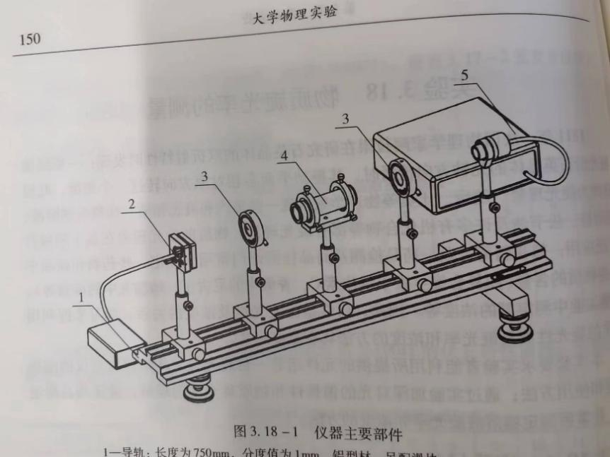

Figure 1 OEX-PSP polarized optical rotation experimental instrument

1. Rail: length: 750mm, division: 1mm, aluminum material, with sliders.
2. Semiconductor laser: wave length: 650nm, power: 2mW, voltage: DC0~3V
3. Polarizer with turntable: rotary scale: 0°~360°, division: 1°
4. Sample tube: length: 200mm
5. Optical power meter: containing light intensity detectors. The range has two levels: 200uW and 2mW, displayed by LED
6. **Experiment**
   1. **Analysis and Explanation of Relevant Principles**
      1. **The Principle of Optical Rotation**

At the fundamental level, polarization rotation in an optically active medium is caused by circular birefringence, and can best be understood in that way. Whereas [linear birefringence](https://en.wikipedia.org/wiki/Birefringence" \o "Birefringence) in a crystal involves a small difference in the [phase velocity](https://en.wikipedia.org/wiki/Phase_velocity" \o "Phase velocity) of light of two different linear polarizations, circular birefringence implies a small difference in the velocities between right and left-handed [circular polarizations](https://en.wikipedia.org/wiki/Circular_polarization" \o "Circular polarization). Think of one enantiomer in a solution as a large number of little helices (or screws), all right-handed, but in random orientations. Birefringence of this sort is possible even in a fluid because the handedness of the helices is not dependent on their orientation: even when the direction of one helix is reversed, it still appears right-handed. And circularly polarized light itself is chiral: as the wave proceeds in one direction the electric (and magnetic) fields composing it are rotating clockwise (or counterclockwise for the opposite circular polarization), tracing out a right (or left) handed screw pattern in space. In addition to the bulk [refractive index](https://en.wikipedia.org/wiki/Refractive_index" \o "Refractive index) which substantially lowers the phase velocity of light in any dielectric (transparent) material compared to the [speed of light](https://en.wikipedia.org/wiki/Speed_of_light" \o "Speed of light) (in vacuum), there is an additional interaction between the chirality of the wave and the chirality of the molecules. Where their chirality are the same, there will be a small additional effect on the wave's velocity, but the opposite circular polarization will experience an opposite small effect as its chirality is opposite that of the molecules [9].

The phase velocity of light in a medium is commonly expressed using the [index of refraction](https://en.wikipedia.org/wiki/Index_of_refraction" \o "Index of refraction) n, defined as the speed of light (in free space) divided by its speed in the medium. The difference in the refractive indices between the two circular polarizations quantifies the strength of the circular birefringence:

$∆n= n_{RHC}− n_{LHC}$ (1)

While $∆n$  is small in natural materials, examples of giant circular birefringence resulting in a negative refractive index for one circular polarization have been reported for chiral metamaterials.

The familiar rotation of the axis of linear polarization relies on the understanding that a linearly polarized wave can as well be described as the superposition (addition) of a left and right circularly polarized wave in equal proportion. The phase difference between these two waves is dependent on the orientation of the linear polarization which we'll call $θ_{0}$ , and their electric fields have a relative phase difference of $2θ_{0}$  which then add to produce linear polarization:

$E_{θ_{0}}= \frac{\sqrt{2}}{2}\left(e^{−iθ_{0}}E_{RHC}+ e^{iθ_{0}}E_{LHC}\right)$ (2)

where $E_{θ_{0}}$  is the electric field of the net wave, while $E_{RHC}$  and $E_{LHC}$  are the two circularly polarized basis functions (having zero phase difference). Assuming propagation in the +z direction, we could write $E_{RHC}$  and $E_{LHC}$  in terms of their x and y components as follows:

$$E_{RHC}=\frac{\sqrt{2}}{2}\left(\hat{x}+i\hat{y}\right)$$

$E_{RHC}=\frac{\sqrt{2}}{2}\left(\hat{x}−i\hat{y}\right)$ (3)

where $\hat{x}$  and $\hat{y}$  are unit vectors, and $i$  is the imaginary unit, in this case representing the 90-degree phase shift between the x and y components that we have decomposed each circular polarization into. As usual when dealing with phasor notation, it is understood that such quantities are to be multiplied by $e^{−iωt}$  and then the actual electric field at any instant is given by the real part of that product.

Substituting these expressions for $E_{RHC}$  and $E_{RHC}$  into the equation for $E_{θ_{0}}$  we obtain:

$$E_{θ_{0}} =\frac{\sqrt{2}}{2}\left(e^{−iθ_{0}}E_{RHC}+ e^{iθ_{0}}E_{LHC}\right)$$

$$=\frac{1}{2} \left[\hat{x}\left(e^{−iθ_{0}}+ e^{iθ_{0}}\right)+\hat{y}\left(e^{−iθ_{0}}− e^{iθ_{0}}\right)\right]$$ $=\hat{x}\cos{θ_{0}}+\hat{y}\sin{θ_{0}}$ (4)

The last equation shows that the resulting vector has the x and y components in phase and oriented exactly in the $θ_{0}$  direction, as we had intended, justifying the representation of any linearly polarized state at angle $θ$  as the superposition of right and left circularly polarized components with a relative phase difference of $2θ$ . Now let us assume transmission through an optically active material which induces an additional phase difference between the right and left circularly polarized waves of $2Δθ$ . Let us call $E_{out}$  the result of passing the original wave linearly polarized at angle $θ$  through this medium. This will apply additional phase factors of $−Δθ$  and $Δθ$  to the right and left circularly polarized components of $E_{θ_{0}}$ :

$E_{out}= \frac{\sqrt{2}}{2}\left(e^{−iΔθ}e^{−iθ_{0}}E_{RHC}+ e^{iΔθ}e^{iθ_{0}}E_{LHC}\right)$ (5)

Using similar math as above we find:

$E_{out}= \hat{x}\cos\left(θ_{0}+ ∆θ\right)+\hat{y}\sin\left(θ_{0}+ ∆θ\right)$ (6)

thus, describing a wave linearly polarized at angle $θ_{0}+ ∆θ$ , thus rotated by $∆θ$  relative to the incoming wave is $E_{θ_{0}}$ .

We defined above the difference in the refractive indices for right and left circularly polarized waves of $Δn$ . Considering propagation through a length $L$  in such a material, there will be an additional phase difference induced between them of $2Δn$   (as we used above) given by:

$2∆θ= \frac{2π∙ΔnL}{λ}$ (7)

where $λ$  is the wavelength of the light (in vacuum). This will cause a rotation of the linear axis of polarization by $∆θ$  as we have shown.

In general, the refractive index depends on wavelength (see dispersion) and the differential refractive index $Δn$  will also be wavelength dependent. The resulting variation in rotation with the wavelength of the light is called optical rotatory dispersion (ORD). ORD spectra and circular dichroism spectra are related through the Kramers–Kronig relations. Complete knowledge of one spectrum allows the calculation of the other.

So, we find that the degree of rotation depends on the color of the light (the yellow sodium $D$ line near 589 nm wavelength is commonly used for measurements), and is directly proportional to the path length $L$  through the substance and the amount of circular birefringence of the material $Δn$  which, for a solution, may be computed from the substance's specific rotation and its concentration in solution.

* + 1. **The formula of optical rotation**

The ratio, the purity, and the concentration of two enantiomers can be measured via polarimetry. Enantiomers are characterized by their property to rotate the plane of linear polarized light. Therefore, those compounds are called optically active and their property is referred to as optical rotation. Light sources such as a light bulb, Tungsten Halogen, or the sun emit electromagnetic waves at the frequency of visible light. Their electric field oscillates in all possible planes relative to their direction of propagation. In contrast to that, the waves of linear-polarized light oscillate in parallel planes.

If light encounters a polarizer, only the part of the light that oscillates in the defined plane of the polarizer may pass through. That plane is called the plane of polarization. The plane of polarization is turned by optically active compounds. According to the direction in which the light is rotated, the enantiomer is referred to as dextro-rotatory or levo-rotatory.

The optical activity of enantiomers is additive. If different enantiomers exist together in one solution, their optical activity adds up. That is why racemates are optically inactive, as they nullify their clockwise and counter clockwise optical activities. The optical rotation is proportional to the concentration of the optically active substances in solution. Polarimeters may therefore be applied for concentration measurements of enantiomer-pure samples. With a known concentration of a sample, polarimeters may also be applied to determine the specific rotation when characterizing a new substance. The specific rotation ${[α]}_{λ}^{T}$  is a physical property and defined as the optical rotation α at a path length l of 1 dm, a concentration c of 10 g/L, a temperature T (usually 20 °C) and a light wavelength λ (usually sodium D line at 589.3 nm):

${[α]}_{λ}^{T}= \frac{100×φ}{l×c}$ (8)

The formula can be described in 2 forms, as shown below:

1. For solid materials with optical rotation characteristics, when polarized light passes through it, the rotation angle $φ$ of the polarization plane is proportional to the thickness $l$ of the solid material through which light passes:

$φ= αl$ (9)

1. For liquids with optical rotation characteristics, when polarized light passes through it and the polarization plane passes through it, the rotation angle x of the polarization plane is proportional to the thickness l of the solution through which light passes and the concentration c of the solution:

$φ= αlc$ (10)

The specific explanation is in Figure 2 below.

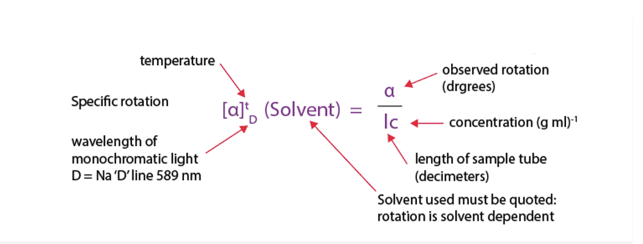

Figure 2 The specific explanation of optical rotation formula

This tells us how much the plane of polarization is rotated when the ray of light passes through a specific amount of optically active molecules of a sample. Therefore, the optical rotation depends on temperature, concentration, wavelength, path length, and the substance being analyzed.

* + 1. **Malus Law**
       1. **Principles**

Malus Law states that when a beam of light propagates in an isotropic uniform medium, it always maintains orthogonality with the wave surface, and the optical path between the corresponding points of the incident and outgoing wave surfaces is constant.

According to electromagnetic wave theory, light is a transverse wave, and its vibration direction is perpendicular to the propagation direction of light. In a plane perpendicular to the direction of light wave propagation, the light vector may have different vibration directions, and the state in which the light vector maintains a certain vibration direction is usually referred to as the polarization state.

The polarized light generated by the polarizer passes through the polarizer, as shown in Figure 3.

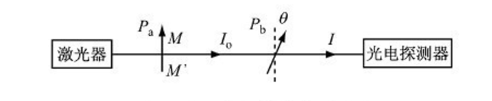

Figure 3 Polarized light passes through the polarizer

$OM$ represents the polarization direction of the polarizer, while $ON$ represents the polarization direction of the polarizer. The angle between them is $α$. After passing through the polarizer, natural light becomes linearly polarized light along the $OM$ direction, with an amplitude of $E_{0}$. However, the polarizer only allows its component in the $ON$ direction to pass through, so the amplitude of the light transmitted from the polarizer is:

$E=E_{0}\cos{α}$ (11)

From this, it can be seen that if the light intensity of the incident polarizer is I0, there is a certain relationship between the light intensity emitted by the polarizer and the original light intensity and the polarizer angle.

* + - 1. **Malus Law Formula**

Malus pointed out through experiments that when linearly polarized light with an intensity of $I_{0}$ passes through the polarizer, the intensity of the transmitted light (without considering absorption) is:

$I=I_{0}\cos{α}$ (12)

Among them, $α$ is the angle between the direction of optical vibration of polarized light entering the ray and the polarization direction of the polarizer. A beam of linearly polarized light with an intensity of I0 passes through the polarizer, and the transmitted light has an intensity of $I=I_{0}\cos{α}$. In the equation the angle $α$ between the vibration direction of linearly polarized light and the transmission direction of the polarizer is called Marius' law.

From this equation, it can be concluded that when $α= 0 ° or 180 °$, where $I=I_{0}$. The transmitted light is strongest when $α= 90 ° or 270 °$, where $I=0$ and the transmitted light intensity is zero. At other values, the light intensity is between 0 and .

* + 1. **The Directionality of Material Rotation**

There are two types of optical matter: left-handed light and right-handed light. When the experimenter observes facing the light, the substance that rotates clockwise on the vibration surface is called right-handed substance, and vice versa is called left-handed substance.

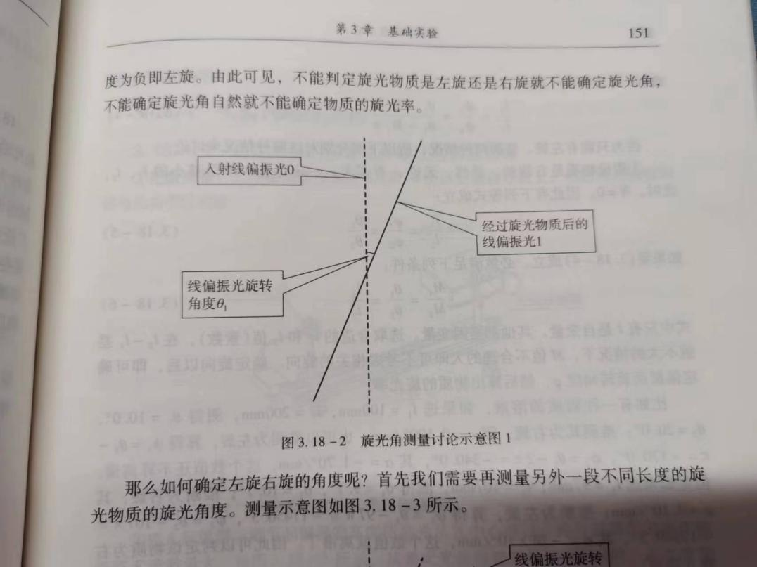

Figure 4 Schematic diagram of polarized light (1)

As shown in Figure 4 above, the rotation period of line (plane) polarized light is 180 °. From Figure 4, it can be seen that we cannot determine whether the linearly polarized light changes from position 0 to position 1 from right rotation $θ_{1}$ degrees or left rotation $180°−θ_{1}$ degrees. In fact (because some substances in nature have very high optical rotation rates, such as quartz crystals), the position of linearly polarized light 1 may satisfy:

$$φ_{1}= N_{1}π+θ_{1}\left(right−handed\right) or$$ $$ψ_{1}= −M_{1}π+θ_{1}\left(left−handed\right), where$$ $N=0, 1, 2,⋯;M=1, 2, ⋯, 180°≥θ_{1}≥0°$ (13)

It is hereby stipulated that: a positive angle indicates right rotation, and a negative angle indicates left rotation. From this, it can be seen that the rotation angle cannot be determined if a substance is left-handed or right-handed, and the rotation rate of the substance cannot be determined if the rotation angle cannot be determined.

Firstly, we need to measure the rotation angle of another section of optically active material with different lengths. The measurement diagram is shown in Figure 5.

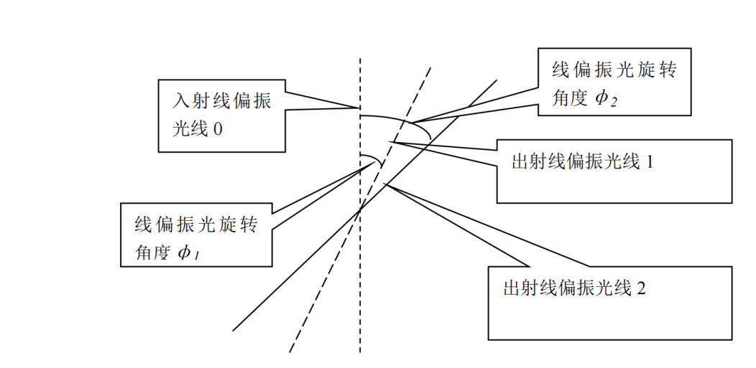

Figure 5 Schematic diagram of polarized light (2)

The position of linearly polarized light 2 may be:

$$φ_{2}= N_{2}π+θ_{2}\left(right−handed light\right) or$$ $$ψ_{2}= M_{2}π+θ_{2}\left(left−handed light\right), where$$ $N=0, 1, 2,⋯;M=1, 2, ⋯, 180°≥θ_{1}≥0°$ (14)

From formula above we can obtain that:

$\frac{l_{1}}{l_{2}}= \frac{φ_{1}}{φ_{2}}= \frac{N_{1}π+θ_{1}}{N_{2}π+θ_{2}} (right−handed)$ (15)

Or:

$\frac{l_{1}}{l_{2}}= \frac{ψ_{1}}{ψ_{2}}= \frac{θ_{1}− M_{1}π}{θ_{2}− M_{2}π} (left−handed)$ (16)

In practical research, due to the unknown size of $α$, the selection of $l_{1}$ and $l_{2}$ may not be small enough. The judgment method at this point is: is to still select $l_{1}$ and $l_{2}$ as prime numbers, where $l_{2}>l_{1}$ and their difference is not large. If measured $θ_{2}>θ_{1}$, it can be determined that the substance is a right-handed optical substance, or it is a left-handed optical substance on the contrary.

* 1. **Purposes of the experiment**

1. Determine the polarization of the light source

2. Verifying Marius' Law

3. Measuring the optical rotation of glucose solution

* 1. **Procedures**
     1. **Determine the Polarization of the Light and Verify Malus Law**

1. Place the laser and light intensity detector on the guide rail, and then connect the light intensity detector with the Optical power meter.
2. Turn on the power switch of the Optical power meter, adjust the range accuracy of the Optical power meter to the thousandth, turn on the semiconductor laser and adjust it to the maximum intensity. When there are no other elements on the guide rail, make the laser input the optical intensity detector vertically. Observe the value change on the optical power meter and adjust its attenuation value to a suitable range.
3. Place a polarizer and adjust the height of the polarizer to allow the laser to pass through its center; Adjust the polarizer angle to maximize the light intensity reading. Start at the maximum light intensity position and rotate for 90°. Change the polarizer angle step by step. Record a set of data every 15°. Judge the polarization state of the light source based on the obtained data. If it is found that the light source is linearly polarized, use these data as $I\sim {(cos{θ)}}^{2}$ to Verify Marius' law.
4. If the light source is not linear polarized light, please adjust the polarizer back to the position where the light intensity reading is the largest, put it in the polarizer, and adjust the polarizer to make the light intensity reading the largest. From this position to the rotation of 90°, change the angle of the polarizer step by step, record a group of data every 15°, and use the obtained data validation Marius Law.
   * 1. **Measuring the Optical Rotation of Glucose Solution**
5. Install and fix the semiconductor laser, polarizer, sample tube bracket, and light intensity detector on the optical holder, and adjust the coaxial contour to make the laser emitted by the laser vertically pass through the center of the polarizer and light intensity detector.
6. Adjust the polarizer turntable to maximize the output polarized light. Fix the polarizer on the slider of the guide rail so that the polarizer is parallel to the polarizer and coaxial at the same height. Rotate the polarizer 360°and observe the changes in light intensity during the rotation process.
7. After adjusting the polarizer turntable and maximizing the light intensity output from the polarizer, record the angle value of the polarizer at this time ${θ_{0}}_{i}$. Place a glucose solution test tube with a mass concentration of $c=15\%$, rotate the polarizer $360°$, adjust the polarizer to maximize the light intensity output from the polarizer, and record the angle of the polarizer at this time $θ_{i}$. Remove the glucose solution test tube, rotate the polarizer $360°$, adjust the polarizer turntable to maximize the light output from the polarizer, and record the angle value of the polarizer again . Repeat the above steps 5 times to obtain five sets of data, and finally calculate the final value and the optical rotation of the glucose solution at this concentration through the differential method.
   1. **Original Data and processing**
      1. **Determining the Polarization of Light with a Single Polarizer**

Place the laser and light intensity detector on the guide rail, and then turn on the power switch of the light intensity detector. When there are no other components on the guide rail, make the laser vertically shoot into the light intensity detector. Place a polarizer and adjust the height of the polarizer to allow the laser to pass through its center. Adjust the angle of the polarizer to maximize the light intensity reading. Starting at the maximum light intensity position and rotating through 90°, change the angle of the polarizer one by one, and record a set of data every 15°, as follows:

|  |  |  |
| --- | --- | --- |
| Measurement times | Deflection angle of polarizer | Light intensity $$\left({10}^{−7}A\right)$$ |
| 1 | 0° | 3.895 |
| 2 | 15° | 3.662 |
| 3 | 30° | 3.149 |
| 4 | 45° | 2.425 |
| 5 | 60° | 1.721 |
| 6 | 75° | 1.264 |
| 7 | 90° | 1.131 |

Table 1 Angle value corresponding to single polarizer

From the data in the table, it can be seen that:

Figure 6 Single polarizer determines the polarization of the light source

According to the least square method, the fitted trend line is:

* + 1. **Determining the Polarization of Light with Multiple Polarizers**

Place the laser and light intensity detector on the guide rail, and then turn on the power switch of the light intensity detector. When there are no other components on the guide rail, make the laser vertically shoot into the light intensity detector. Place the polarizer and polarizer, and adjust the height of the polarizer and polarizer to allow the laser to pass through its center. Adjust the polarizer to the position where the light intensity reading is maximum, place the polarizer, and adjust the polarizer to maximize the light intensity reading. From this position to rotate 90°, change the angle of the polarizer one by one, and record a set of data every 15°, as follows:

|  |  |  |
| --- | --- | --- |
| Measurement times | Deflection angle of polarizer | Light intensity $$\left({10}^{−7}A\right)$$ |
| 1 | 0° | 2.841 |
| 2 | 15° | 2.745 |
| 3 | 30° | 2.309 |
| 4 | 45° | 1.662 |
| 5 | 60° | 0.958 |
| 6 | 75° | 0.412 |
| 7 | 90° | 0.133 |

Table 2 Angle value corresponding to multiple polarizers

From the drawing of the data in the table, it can be concluded that:

Figure 7 Using polarizers and detectors to determine the polarization of the light source

According to the least square method, the fitted trend line is:

$$ŷ = −0.0337x + 3.0951(where { R}^{2}= 0.9743)$$

It was observed that the correlation coefficient was large and the data showed a linear decreasing trend, indicating that the light source was linearly polarized.

* + 1. **Verifying Malus' Law**

By simultaneously using the polarizer and the polarizer to determine the experimental data in the polarization of the light source, the polarizer deflection angle $θ$ is changed to ${(cos{θ)}}^{2}$:

|  |  |  |  |
| --- | --- | --- | --- |
| Measurement times | Deflection angle $θ$ of polarizer | $${(cos{θ)}}^{2}$$ | Light intensity $$\left({10}^{−7}A\right)$$ |
| 1 | 0° | 1 | 2.841 |
| 2 | 15° | 0.933 | 2.745 |
| 3 | 30° | 0.75 | 2.309 |
| 4 | 45° | 0.5 | 1.662 |
| 5 | 60° | 0.25 | 0.958 |
| 6 | 75° | 0.06 | 0.412 |
| 7 | 90° | 0 | 0.133 |

Table 3 Data obtained from the Malus experiment

And draw the relationship diagram of $I\sim {(cos{θ)}}^{2}$ as follows:

Figure 8 Verifying Malus' Law (1)

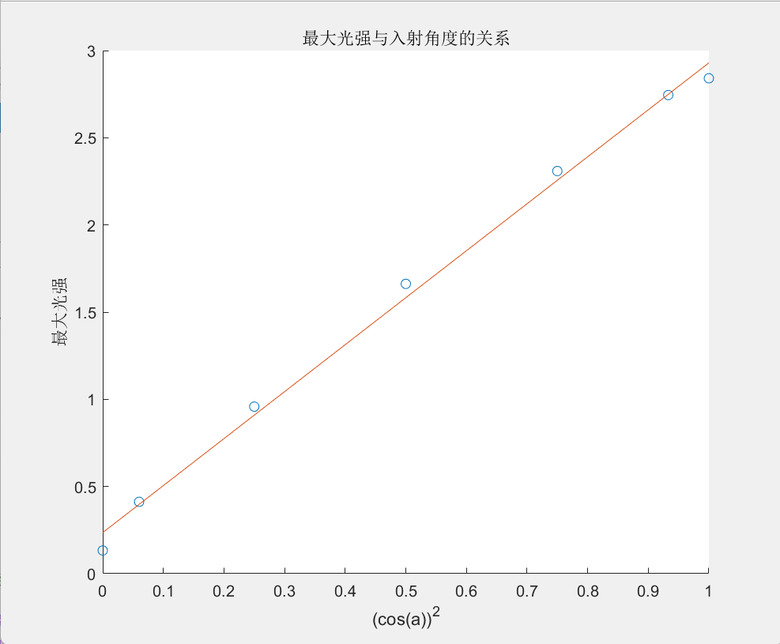

Figure 9 Verifying Malus' Law (2)

According to the least square method, the fitted trend line is:

$$ŷ = 2.6937x + 0.2358(where{ R}^{2}=0.9959)$$

The correlation coefficient is large, so $I$ is proportional to ${(cos{θ)}}^{2}$, which conforms to Marius' law.

* + 1. **Measuring the Optical Rotation of Glucose Solution**

After adjusting the polarizer turntable and maximizing the light intensity output from the polarizer, record the angle value of the polarizer at this time ${θ_{0}}_{i}$. Place a glucose solution test tube with a mass concentration of $c=15\%$, rotate the polarizer 360°, adjust the polarizer to maximize the light intensity output from the polarizer, and record the angle of the polarizer at this time $θ_{i}$. Remove the glucose solution test tube, rotate the polarizer 360°, adjust the polarizer turntable to maximize the light output from the polarizer, and record the angle value ${θ_{0}}_{i}^{'}$ of the polarizer again. Repeat the above steps 5 times to obtain five sets of data, and finally calculate the final value and the optical rotation of the glucose solution at this concentration through the differential method.

In the experiment of measuring the optical rotation of glucose solution, we obtained the original data as shown in the following figure:

|  |  |  |  |  |  |
| --- | --- | --- | --- | --- | --- |
| Initial Angle | $$120°$$ | $$110°$$ | $$120°4'$$ | $$114°52'$$ | $$116°$$ |
| Change Angle | $$133°24'$$ | $$124°16'$$ | $$134°06'$$ | $$127°08'$$ | $$128°08'$$ |
| Rotation Angle | $$13°24'$$ | $$14°16'$$ | $$13°26'$$ | $$12°16'$$ | $$12°08'$$ |

Table 4 Original data of experiment for measuring the optical rotation of glucose solution

After conversion, the percentage angle obtained is:

$$φ_{1}=13.4{, φ}_{2}=14.27, φ_{3}=13.43,φ_{4}=12.27,φ_{5}=12.13$$

$$\overline{φ}=\frac{φ_{1} + φ_{2} + φ_{3} + φ_{4 }+ φ_{5}}{5}= 13.10°$$

The optical rotation of the glucose solution is:

$$φ= \overline{φ}=13.10°$$

Measure the length of the solution test tube:

$$l=1.66 ±0.01 dm$$

Known solution mass concentration:

$$c=0.15g/{dm}^{3}$$

Reach $α$ Optical rotation:

$$φ= αlc$$

$$α= \frac{φ}{lc}=52.61(° ∙ {cm}^{3 }∙ g^{−1}∙ {dm}^{−1})$$

Take natural logarithm on both sides of the function:

$$lnα=lnφ−lnL−lnc$$

Taking the total differential, we obtain:

$$\frac{dα}{α}=\frac{dφ}{φ}−\frac{dL}{L}−\frac{dc}{c}$$

Substitute the error amount for the differential component, take the sum of the squares of each term, and then multiply the square:

$$\frac{σ_{α}}{α}=\sqrt{{\left(\frac{σ_{φ}}{φ}\right)}^{2}+{\left(\frac{σ_{L}}{L}\right)}^{2}+{\left(\frac{σ_{c}}{c}\right)}^{2}}=\sqrt{{\left(\frac{0.01}{1.66}\right)}^{2}}= 0.00602$$

Calculate the standard deviation, and obtain:

$$σ_{α}=α∙\frac{σ_{α}}{α}=0.32(°∙ {cm}^{3 }∙ g^{−1}∙ {dm}^{−1})$$

So, the measured optical rotation is:

* 1. **Data Analysis**

In the experiment to determine the polarization of the light source, we obtained data with a large linear correlation coefficient fitting, and the data showed a linear decreasing trend, which determined that the light source was polarized light.

In verifying Marius' law, we linearly fitted the data and obtained a fitted straight line with $R^{2}$ very close to 1, and the light intensity I corresponds to $\cos^{2}θ$. Demonstrate a significant linear relationship and a monotonically increasing function, thereby successfully verifying Marius' law.

In the experiment of measuring the optical rotation of glucose solution, we took into account the significant impact of environmental errors, so after each 15°rotation of the polarizer, the initial angle of the polarizer will be measured again to achieve the effect of reducing errors. After reading the angle once, rotate $P_{2}$ 360 $°$ and read again to reduce contingency. Note that $P_{2}$ must be rotated in one direction to eliminate pitch error.

The experimental results are relatively ideal, and the data can prove that the optical rotation of glucose solution is within the standard value error.

However, sometimes we may probably run into experimental errors when doing this experiment. As a result, there can be several possible reasons for experimental errors in the experiments. Here are some common factors that could contribute to errors:

1. Equipment limitations: The quality and calibration of the equipment used in the experiments can affect the accuracy of the measurements. If the polarizers or other optical components are not properly aligned or calibrated, it can lead to inaccurate results.
2. Environmental factors: The presence of external light sources or ambient light can interfere with the measurements, especially in experiments involving polarized light. It is important to conduct the experiments in a controlled environment with minimal external light sources.
3. Imperfect polarization: Polarizers are designed to transmit light of a specific polarization direction while blocking light of other polarizations. However, they are not perfect and can have some degree of imperfections or deviations from the desired polarization characteristics. This can introduce errors in the measurements.
4. Human error: Mistakes made during the setup, alignment, or measurement process can lead to experimental errors. For example, misalignment of the polarizers, inaccurately reading the measurements, or improper handling of the samples can all contribute to errors.
5. Sample impurities or variations: In experiments involving samples, such as measuring the optical rotation of a glucose solution, impurities or variations in the sample can affect the measurements. Impurities in the sample can introduce additional optical effects or alter the polarization characteristics, leading to errors.
6. Insufficient data or statistical variations: In experiments that involve data collection and analysis, errors can arise from insufficient data points or statistical variations. Taking a limited number of measurements or not considering the statistical uncertainty can lead to inaccuracies in the results.
7. Systematic errors: Systematic errors can occur due to inherent biases or flaws in the experimental setup or methodology. These errors tend to consistently affect the measurements in a particular direction, leading to inaccuracies in the results.
8. **Discussion**
   1. **Beer-Lambert Law Applying on the Optical Rotation**
      1. **The Beer-Lambert Law**

The Beer-Lambert law is commonly applied to [chemical analysis](https://en.wikipedia.org/wiki/Chemical_analysis" \o "Chemical analysis) measurements to determine the concentration of chemical species that absorb light. It is often referred to as Beer's law. In [physics](https://en.wikipedia.org/wiki/Physics" \o "Physics), the Bouguer–Lambert law is an [empirical law](https://en.wikipedia.org/wiki/Empirical_law" \o "Empirical law) which relates the extinction or [attenuation](https://en.wikipedia.org/wiki/Absorption_(electromagnetic_radiation)" \o "Absorption (electromagnetic radiation)) of [light](https://en.wikipedia.org/wiki/Light" \o "Light) to the properties of the material through which the light is travelling. It had its first use in [astronomical extinction.](https://en.wikipedia.org/wiki/Extinction_(astronomy)" \o "Extinction (astronomy)) The fundamental law of extinction (the process is linear in the intensity of radiation and amount of radiatively active matter, provided that the physical state is held constant) is sometimes called the Beer-Bouguer-Lambert law or the Bouguer-Beer-Lambert law or merely the extinction law. The extinction law is also used in understanding attenuation in [physical optics](https://en.wikipedia.org/wiki/Physical_optics" \o "Physical optics), for [photons](https://en.wikipedia.org/wiki/Photons" \o "Photons), [neutrons](https://en.wikipedia.org/wiki/Neutrons" \o "Neutrons), or [rarefied gases](https://en.wikipedia.org/wiki/Rarefied_gas" \o "Rarefied gas). In [mathematical physics](https://en.wikipedia.org/wiki/Mathematical_physics" \o "Mathematical physics), this law arises as a solution of the [BGK equation](https://en.wikipedia.org/wiki/Bhatnagar%E2%80%93Gross%E2%80%93Krook_operator" \o "Bhatnagar–Gross–Krook operator) [10].

* + 1. **The Formula of Beer-Lambert Law**

A beam of Monochromatic radiation shines on the surface of an absorbing medium. After passing through the medium with a certain thickness, the intensity of the transmitted light will be weakened because the medium absorbs part of the light energy. The higher the concentration and thickness of the absorbing medium, the more significant the decrease in light intensity. The relationship is:

$A= −\log_{10}\frac{I_{t}}{I_{0}}= \log_{10}\frac{1}{T}=K∙l∙c$ (17)

Among them:

$A$: Absorbance;

$I_{0}$: Intensity of incident light;

$I_{t}$: The intensity of transmitted light;

$T$: Transmittance;

$K$: Coefficient, which can be absorption coefficient or molar absorption coefficient;

$l$: The thickness of the absorbing medium, usually measured in centimeter;

$c$: The concentration of the absorbing substance, which can be expressed in g/L or mol/L.

The physical meaning of Beer–Lambert law is that when a parallel Monochromatic radiation vertically passes through a uniform and non-scattering light absorbing substance, its absorbance is proportional to the concentration of the light absorbing substance and the thickness of the absorption layer. When the medium contains multiple absorbance components, as long as there is no interaction between the components, the total absorbance of the medium at a certain wavelength is the sum of the absorbances of each component at that wavelength. This law is called the additivity of absorbance. Coefficient K:

Assuming a beam strength of $I_{0}$ parallel Monochromatic radiation light (incident light) vertically shines on the surface of an isotropic uniform absorption medium. After passing through the absorption layer (optical path) with a thickness of $l$, the intensity of the beam of incident light decreases to $I_{1}$ due to the absorption of light by particles in the absorption layer which is called the intensity of transmitted light. The ability of a substance to absorb light is directly proportional to the cross-sectional area of all light absorbing particles. Imagine that the absorption layer with a thickness of $l$ can be divided into multiple infinitely small thin layers dl in the direction perpendicular to the incident light, with a cross-sectional area of $S$, and each layer contains $dn$ absorbing particles with a cross-sectional area of $a$. Therefore, the total cross-sectional area of all light absorbing particles within this thin layer $dS=a dn$.

Assuming that the incident light with intensity $I$ is irradiated on the thin layer, the light intensity weakens $dI$. $dI$ is a measure of the degree of light absorption in a small thin layer, which is proportional to the total cross-sectional area $dS$ of the absorbing particles in the thin layer and the intensity $I$ of the incident light, that is:

$−dI= k_{1}∙I∙dS= k_{1}∙I∙a∙dn$ (18)

A negative sign indicates a decrease in light intensity due to absorption, and $k_{1}$ is the proportional coefficient. Assuming the concentration of the light absorbing substance is $c$, the number of light absorbing points in the above thin layer is:

$dn=6.02× {10}^{23}cSdl$ (19)

Substitute it into the above equation, merge the constant terms and set $k_{2}=6.02×{10}^{23}k_{1}aS$, and after sorting, obtain:

$−\frac{dI}{I}= k_{2}cdl$ (20)

By integrating the above equation, there is:

$$−\int_{I_{0}}^{I_{1}}{\frac{dI}{I}}= \int_{0}^{1}{k_{2}∙c∙dl}$$

$$−ln\frac{dI}{I}= \int_{0}^{1}{k_{2}cl}$$

$\log_{10}\frac{I_{0}}{I_{1}}=0.434k_{2}cl=Klc$ (21)

In the above equation, $\log_{10}\frac{I_{0}}{I_{1}}$ is called absorbance (A); The ratio $\frac{I_{0}}{I_{1}}$ between the intensity of transmitted light and the intensity of incident light is called transmittance, or transmittance (T), and its relationship is:

$A= −\log_{10}\frac{I_{t}}{I_{0}}= \log_{10}\frac{1}{T}=K∙l∙c$ (22)

Converting the above formula can convert the absorbance value A to the concentration of the substance:

$c= \frac{A}{k∙l}$ (23)

Using the concentration value c and the known optical path l, according to the definition formula of optical rotation:

$\left[α\right]= \frac{φ}{l∙c}$ (24)

By using this formula, the proportional relationship between concentration and optical rotation can be converted into a numerical value of optical rotation.

It should be noted that the molar absorption coefficient $k$ is a constant related to material properties and usually needs to be obtained from literature or related experiments. In addition, the optical path $l$ is the path length of the cuvette, which can be directly measured in experiments or obtained based on the specifications of the cuvette.

Attention:

Beer–Lambert law is based on the premise that:

1. The incident light is parallel Monochromatic radiation light and vertically irradiated; The absorbing material is a uniform non scattering system;
2. There is no interaction between absorbing particles;
3. The interaction between radiation and matter is limited to the process of light absorption, with no fluorescence or photochemical phenomena occurring.
   * 1. **The Application of Beer-Lambert Law**

The Lambert-Beer law, also known as the Beer-Lambert law, can be used to determine the optical rotation of a substance. This method is based on the principle that describes the absorption of light when it passes through an absorbing medium.

The experimental procedure is as follows:

1. Prepare a cuvette: Select a cylindrical or square cuvette and ensure that it is clean and free from contamination.
2. Prepare the sample solution: Obtain a solution of the substance under investigation, ensuring that its concentration is appropriate for the range of optical rotation to be measured.
3. Adjust the wavelength: Choose a suitable wavelength, typically using an adjustable light source, to irradiate the sample solution in the cuvette. The wavelength selection is usually dependent on the characteristics of the substance and the experimental equipment.
4. Measure the transmitted light intensity: Use the light source to illuminate the sample solution in the cuvette, and measure the intensity of the transmitted light using a photodiode, photomultiplier tube, or spectrophotometer.
5. Prepare a blank sample: Remove the sample solution and replace it with a pure solvent or blank sample.
6. Measure the transmitted light intensity again: Use the same light source and photodetector to measure the intensity of the transmitted light through the blank sample.
7. Calculate the absorbance: Calculate the absorbance of the sample by taking the ratio of the transmitted light intensities. The absorbance can be calculated using the following formula:

$A = log10(I_{0} / I)$ (25)

1. Plot a calibration curve of absorbance versus substance concentration: Measure the absorbance of a series of standard solutions with known concentrations to establish a calibration curve. This curve can be used for subsequent calculations.
2. Measure the optical rotation of the substance under investigation: Using the same experimental conditions and steps, measure the absorbance of the solution of the substance and calculate its concentration using the calibration curve. Then, apply the Lambert-Beer law to convert the absorbance to the optical rotation of the substance.
   * 1. **Pros and Cons of the Method**

The Lambert-Bier method has the following advantages and disadvantages as a method for determining the spin rate of a substance:

Advantages:

1. Simplicity and economy: The Lambert-Bier method uses simple experimental equipment, such as cuvettes, light sources and photodetectors, which is relatively inexpensive and easy to implement.
2. Quantitative: By establishing a standard curve, a quantitative relationship can be established between absorbance and concentration of the substance, thus enabling quantitative measurement of the spin rate.
3. Wide applicability: Lambert-Bier method is applicable to most substances in solution, whether organic or inorganic compounds, as long as the conditions of linear absorption and spin are met.
4. Relative Accuracy: Under appropriate experimental conditions, the Lambert-Bier method can provide relatively accurate spin rate measurements, especially in the appropriate concentration range.

Disadvantages:

1. Limitations: Lambert-Bier method has some limitations on the linear relationship between absorbance and spin. The accuracy of the method can be compromised if the change in spin of the substance with concentration is not linear, or if the relationship between absorbance and concentration is not linear.
2. Dependence: The accuracy of the method is dependent on the accuracy of the molar absorbance coefficient, which usually needs to be obtained from the literature or from relevant experiments and may vary depending on the experimental conditions.
3. Solution condition limitations: The Lambert-Bier method requires the substance to be in solution form, so for solid or non-soluble substances, they need to be dissolved in a suitable solvent in order to be measured.
   1. **Left and Right Spin Light Elimination Method**
      1. **Principles**

When light passes through a spiny substance, its polarization direction is rotated, and this rotation angle is the rotational luminosity of the substance. The left-right rotation light elimination method utilizes the symmetry principle of the rotational luminosity to eliminate the asymmetry error of the experimental system.

In the experiment, the spin luminosity ($α_{l}$) of the substance solution in the left rotation light direction is first measured, and then the sample solution is reversed or stereoisomers (such as D- and L-isomers) are used to measure the spin luminosity ($α_{r}$) in the right rotation light direction.

According to the definition of the rotational luminosity, the left and right rotational luminosity can be expressed as:

$α_{l} = [α] ∙ l ∙ c$ (26)

$α_{r} = −[α] ∙ l ∙ c$ (27)

where [α] denotes the rotational luminosity, l denotes the optical range (path length of the cuvette), and c denotes the concentration of the substance.

Then, the values of the left and right rotational luminosities were averaged to obtain the average rotational luminosity ($\overline{α}$):

$\overline{α} = (α_{l} + α_{r}) / 2$ (28)

According to the above expression, it can be found that the sign of the left and right spin luminosity is opposite, so their average value is zero. This means that the asymmetry error of the experimental system can be eliminated by the left-right rotational light elimination method, and the result of zero average rotational luminosity can be obtained.

If there is no asymmetry in the experimental system, the left and right spin luminosities should be equal, which is $α_{l}$ = $α_{r}$. However, in practice, factors such as asymmetry in the experimental conditions, apparatus or solvent can lead to small differences in the left and right spin luminosities. These differences can be eliminated by calculating the average of the left and right rotational luminosities, thus reducing systematic errors and obtaining more accurate rotational index measurements.

By the left-right spin elimination method, we can eliminate the errors caused by the asymmetry of the experimental system, and thus obtain more reliable and accurate results for the measurement of the spin rate of substances.

* + 1. **Content Step**

1. Prepare the sample solution: Take a certain amount of the substance to be measured and dissolve it into a suitable solvent to get the solution of the desired concentration.
2. Set up the instrument: According to the experimental requirements, set up the parameters of the polarizing light meter, including wavelength, temperature and light range, etc.
3. Measure the left rotational luminosity: Using the rotameter or polarimeter, measure the left rotational luminosity of the solution of the substance to be measured and record the value.
4. Measure right rotational luminosity: Under the same experimental conditions, invert the sample or replace the stereoisomers of the sample (e.g., D- and L-isomers), measure the right rotational luminosity, and record the value.
5. Eliminate the difference in rotation direction: Average the values of left and right rotational luminosity to obtain the average rotational luminosity.
6. Calculate optical rotation: Use the above formula to calculate optical rotation:
   * 1. **Advantages of the Method**

The left and right rotation elimination method can be seen as an improvement on the polarimeter method. The following are several advantages of the left and right rotation elimination method compared to traditional polarimeter methods:

1. Eliminating systematic errors: the left and right rotation elimination method eliminates asymmetric errors in the experimental system by measuring left and right rotations and taking their average values. This method can effectively eliminate Systemic bias caused by instrument, solvent or other system factors, and improve the accuracy of measurement results.
2. Improving accuracy: By eliminating the asymmetry error of the experimental system, the left and right rotation elimination method can obtain more accurate rotation measurement results. It can reduce experimental repeatability errors and the impact of environmental factors on measurement results, thereby improving measurement accuracy.
3. Reduce experimental time and sample requirements: Compared to traditional polarimeter methods, the left and right rotation elimination method only requires measuring left and right rotations once, and taking the average value, thereby reducing experimental time and sample requirements. This makes the experimental process more efficient and allows for better utilization of limited sample resources.
4. Suitable for asymmetric samples: The left and right rotation elimination method is particularly effective for samples with significant asymmetry.
5. For these samples, due to their inherent asymmetry, traditional polarimeter methods may lead to significant systematic errors. The left and right rotation elimination method can more accurately measure the optical rotation of these asymmetric samples by measuring left and right rotations and eliminating their differences.
6. **Conclusions**

The aim of this study is to investigate optical properties by measuring the optical rotation rate of a substance using a polarimeter and verifying Marius' law. Through experiments, we successfully achieved these goals and obtained some valuable results.

Firstly, we measured the optical rotation of different substances using a polarimeter. By selecting different samples and controlling experimental conditions, we obtained accurate optical rotation data. These results validate the reliability and accuracy of the polarimeter, demonstrating its effectiveness in measuring the optical rotation of substances.

Secondly, we further deepened our understanding of the phenomenon of optical rotation by verifying Marius' law. The experiment proved the effectiveness of Marius' law, which states that the optical rotation is proportional to the product of sample concentration and optical path. This result is consistent with theoretical expectations and further validates the basic principle of optical rotation phenomenon.

We also verified the polarization of the light source to ensure that it is polarized during the experiment. This step is crucial for accurately measuring optical rotation, as non-polarized light may introduce errors. By using tools such as polarizers and polarizers, we ensured that the light source in the experiment was polarized and eliminated potential errors caused by polarization.

Finally, we successfully measured the optical rotation of glucose solution. By using a polarimeter and calculating according to Marius' law, we determined the optical rotation of glucose solution and obtained accurate optical rotation values. This result is of great significance for the study of optical properties and practical applications of glucose solutions.

In the discussion section, we also introduced two other commonly used methods for measuring the optical rotation of substances: the Lambert Beer method and the left and right optical rotation elimination method. These methods have their own advantages and disadvantages, and appropriate methods can be selected for optical rotation measurement based on actual needs.

In summary, through this experiment, we successfully measured the optical rotation of matter using a polarimeter and verified Marius' law and the polarization of the light source. Our research results are of great significance for the understanding and practical application of optical properties, and provide a foundation for further exploration of optical rotation phenomena. In addition, we also introduced two other commonly used methods, providing researchers with more choices and references. These research results have important guiding significance for the research and application of chemistry, pharmacy, Food science and other fields.

However, it should be noted that the measurement of optical rotation is still influenced by some factors, such as sample purity, solvent selection, and temperature stability. In future research, we can further optimize experimental conditions and methods to improve measurement accuracy and sensitivity.

In summary, through this experiment, we explored the methods for measuring the optical rotation of substances and achieved some meaningful results. These results are of great significance for in-depth understanding of optical properties, studying material structures, and developing related applications, and provide reference and guidance for further research.

1. **References**

[1] Arago (1811) "Mémoire sur une modification remarquable qu'éprouvent les rayons lumineux dans leur passage à travers certains corps diaphanes et sur quelques autres nouveaux phénomènes d'optique" (Memoir on a remarkable modification that light rays experience during their passage through certain translucent substances and on some other new optical phenomena), Mémoires de la classe des sciences mathématiques et physiques de l'Institut Impérial de France, 1st part: 93–134.

[2] Herschel, J.F.W. (1820) "On the rotation impressed by plates of rock crystal on the planes of polarization of the rays of light, as connected with certain peculiarities in its crystallization," Transactions of the Cambridge Philosophical Society, 1: 43–51.

[3] Biot, J. B. (1815) "Phenomene de polarisation successive, observés dans des fluides homogenes" (Phenomenon of successive polarization, observed in homogeneous fluids), Bulletin des Sciences, par la Société Philomatique de Paris, 190–192.

[4] Biot (1818 & 1819) "Extrait d'un mémoire sur les rotations que certaines substances impriment aux axes de polarisation des rayons lumineux" (Extract from a memoir on the [optical] rotations that certain substances impress on the axes of polarization of light rays), Annales de Chimie et de Physique, 2nd series, 9 : 372-389 ; 10 : 63-81 ; for Biot's experiments with turpentine vapor (vapeur d'essence de térébenthine), see pp. 72-81.

[5] A. Fresnel, "Mémoire sur la double réfraction que les rayons lumineux éprouvent en traversant les aiguilles de cristal de roche suivant les directions parallèles à l'axe", read 9 December 1822; printed in H. de Senarmont, E. Verdet, and L. Fresnel (eds.), Oeuvres complètes d'Augustin Fresnel, vol. 1 (1866), pp. 731–51; translated as "Memoir on the double refraction that light rays undergo in traversing the needles of quartz in the directions parallel to the axis", Zenodo: 4745976, 2021.

[6] Silverman, M.; Ritchie, N.; Cushman, G.; Fisher, B. (1988). "Experimental configurations using optical phase modulation to measure chiral asymmetries in light specularly reflected from a naturally gyrotropic medium". Journal of the Optical Society of America A. 5 (11): 1852.

[7] Silverman, M.; Badoz, J.; Briat, B. (1992). "Chiral reflection from a naturally optically active medium". Optics Letters. 17 (12): 886. Bibcode:1992OptL...17..886S. doi:10.1364/OL.17.000886. PMID 19794663.[8] University Physics Experiment [M]. South China University of Technology Press, Shaojiang Huang, Mingdong Chen, Eds., 2022

[9] Wikipedia contributors. (2023, May 18). Optical rotation. Retrieved June 18, 2023, from <https://en.wikipedia.org/wiki/Optical_rotation>

[10] Wikipedia contributors. (2023, June 13). Lambert-Beer law. In Wikipedia, The Free Encyclopedia. Retrieved June 18, 2023, from <https://en.wikipedia.org/wiki/Lambert-Beer_law>